LAB EXPERIMENT 10

AIM

To design and develop an Online Fashion Shopping System (StyleHub) using HTML, CSS, and JavaScript that allows users to browse fashion products, search and filter items by category, check product availability, add or remove items from the shopping cart, place orders, and check order status. The system also enables administrators to add, remove, and update product details and prices.

PROCEDURE

Create a project folder named StyleHub and create an HTML file named index.html.

Design the home page using HTML to display clothing, footwear, and accessories.

Use CSS to style the website and provide a user-friendly interface.

Use JavaScript to display products under categories such as men, women, children, footwear, and accessories.

Implement product search and category filtering features.

Add functionality to check product availability and display product details.

Create a shopping cart that allows users to add, edit, and remove products.

Implement the checkout process to place orders and generate an order ID.

Develop an order status checking feature.

Create an admin section to add and remove products and manage product prices.

Run the website in a browser and test all the functionalities.

<!DOCTYPE html>

<html>

<head>

<title>StyleHub Fashion Store</title>

<style>

body{font-family:Arial;margin:20px;background:#f5f5f5}

h1{text-align:center;background:#222;color:white;padding:15px}

input,select,button{padding:8px;margin:5px}

.products{display:flex;flex-wrap:wrap;gap:15px}

.card{background:white;padding:15px;width:200px;border-radius:8px}

button{background:#e91e63;color:white;border:0;cursor:pointer}

#cart{background:white;padding:15px;margin-top:20px}

</style>

</head>

<body>

<h1>StyleHub - Online Fashion Store</h1>

<input id="search" placeholder="Search fashion items" oninput="showProducts()">

<select id="category" onchange="showProducts()">

<option>All</option><option>Men</option><option>Women</option>

<option>Children</option><option>Footwear</option><option>Accessories</option>

</select>

<div id="products" class="products"></div>

<div id="cart">

<h2>Shopping Cart</h2>

<div id="items"></div>

<p id="total">Total: ₹0</p>

<button onclick="checkout()">Checkout</button>

</div>

<h2>Check Order Status</h2>

<input id="orderId" placeholder="Enter Order ID">

<button onclick="checkStatus()">Check Status</button>

<p id="status"></p>

<h2>Admin - Add Fashion Item</h2>

<input id="pname" placeholder="Product Name">

<input id="price" type="number" placeholder="Price">

<select id="pcat">

<option>Men</option><option>Women</option>

<option>Children</option><option>Footwear</option><option>Accessories</option>

</select>

<button onclick="addProduct()">Add Product</button>

<script>

let products=[

{name:"Men's Shirt",price:799,cat:"Men",stock:10,desc:"Casual cotton shirt"},

{name:"Women's Dress",price:1299,cat:"Women",stock:8,desc:"Elegant fashion dress"},

{name:"Kids T-Shirt",price:399,cat:"Children",stock:12,desc:"Comfortable kids wear"},

{name:"Sneakers",price:1499,cat:"Footwear",stock:6,desc:"Stylish everyday footwear"},

{name:"Handbag",price:999,cat:"Accessories",stock:5,desc:"Fashionable handbag"}

];

let cart=[],orders=[];

function showProducts(){

let s=document.getElementById("search").value.toLowerCase();

let c=document.getElementById("category").value;

document.getElementById("products").innerHTML="";

products.filter(p=>p.name.toLowerCase().includes(s)&&(c==="All"||p.cat===c)).forEach((p,i)=>{

document.getElementById("products").innerHTML+=

`<div class="card"><h3>${p.name}</h3><p>${p.desc}</p>

<p>Category: ${p.cat}</p><p>Price: ₹${p.price}</p>

<p>Available: ${p.stock}</p>

<button onclick="addCart(${products.indexOf(p)})">Add to Cart</button>

<button onclick="removeProduct(${products.indexOf(p)})">Remove</button></div>`;

});

}

function addCart(i){

if(products[i].stock<=0)return alert("Out of stock");

let x=cart.find(a=>a.i===i);

if(x)x.qty++;else cart.push({i,qty:1});

products[i].stock--;showProducts();showCart();

}

function showCart(){

let total=0;

document.getElementById("items").innerHTML=cart.map((x,j)=>{

let p=products[x.i];total+=p.price*x.qty;

return `${p.name} - ₹${p.price} x ${x.qty}

<button onclick="changeQty(${j},1)">+</button>

<button onclick="changeQty(${j},-1)">-</button>

<button onclick="removeCart(${j})">Remove</button>`;

}).join("<br>");

document.getElementById("total").innerText="Total: ₹"+total;

}

function changeQty(j,n){

let x=cart[j];

if(n>0&&products[x.i].stock>0){x.qty++;products[x.i].stock--;}

else if(n<0){x.qty--;products[x.i].stock++;if(x.qty===0)cart.splice(j,1);}

showProducts();showCart();

}

function removeCart(j){

let x=cart[j];products[x.i].stock+=x.qty;

cart.splice(j,1);showProducts();showCart();

}

function removeProduct(i){

if(cart.some(x=>x.i===i))return alert("Remove item from cart first");

products.splice(i,1);showProducts();

}

function checkout(){

if(!cart.length)return alert("Cart is empty");

let id="SH"+Math.floor(Math.random()*9000+1000);

orders.push({id,status:"Order Placed",items:cart.map(x=>({name:products[x.i].name,qty:x.qty}))});

alert("Order placed! Order ID: "+id);

cart=[];showCart();showProducts();

}

function checkStatus(){

let o=orders.find(x=>x.id===document.getElementById("orderId").value);

document.getElementById("status").innerText=o?o.status:"Order not found";

}

function addProduct(){

let name=document.getElementById("pname").value;

let price=Number(document.getElementById("price").value);

let cat=document.getElementById("pcat").value;

if(!name||price<=0)return alert("Enter valid details");

products.push({name,price,cat,stock:5,desc:"New fashion item"});

showProducts();alert("Product added successfully");

}

showProducts();

</script>

</body>

</html>

IMPLEMENTATION
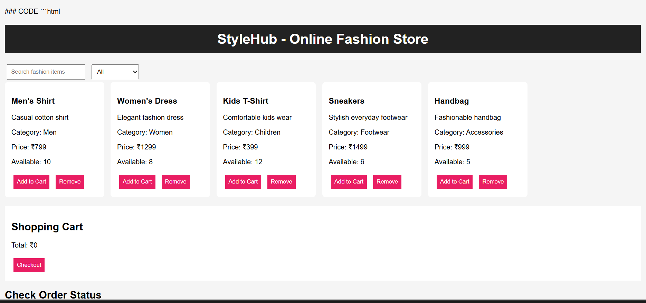

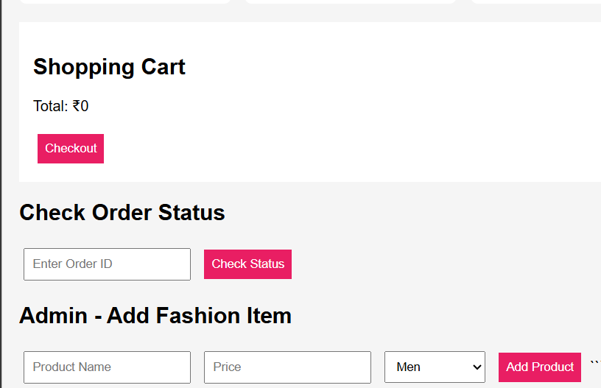

RESULT
Thus, the Online Fashion Shopping System (StyleHub) was successfully designed and implemented using HTML, CSS, and JavaScript. The system allows users to browse fashion products, search and filter items by category, check product availability, manage the shopping cart, place orders, and check order status. The administrator can add and remove products, providing a simple and user-friendly online shopping experience.

